Supporting Graduate Student Mental Health and Well-being

Communications Toolkit

Contents Include:
p. 1 Sample Newsletter Blurbs
p. 2 Sample Press Release Template
pp. 3-5 Sample Tweets

Sample Newsletter Blurb – Generic Option
CGS & JED Release Evidence-Informed Recommendations and Resources to Support Graduate Student Mental Health and Well-being
On April 29, the Council of Graduate Schools (CGS) and The Jed Foundation (JED) released a report, “Supporting Graduate Student Mental Health and Well-being: Evidence-Informed Recommendations for the Graduate Community,” which provides an evidence base for future action to support graduate student well-being, along with recommendations for key stakeholders. The report’s findings and recommendations are intended to provide a starting point for discussion and action for all campus groups with a vested interest in the quality of graduate education. To date over 150 universities have endorsed the report’s statement of principles to show their commitment to supporting graduate student mental health and well-being.
Sample Newsletter Blurb – University Signatories
<University Name> Endorses CGS/JED Statement of Principles & Commitments to Support Graduate Student Mental Health & Well-being
On April 29, the Council of Graduate Schools (CGS) and The Jed Foundation (JED) released a report, “Supporting Graduate Student Mental Health and Well-being: Evidence-Informed Recommendations for the Graduate Community,” which provides an evidence base for future action to support graduate student well-being, along with recommendations for key stakeholders. The report’s findings and recommendations are intended to provide a starting point for discussion and action for all campus groups with a vested interest in the quality of graduate education. <University Name> is proud to be one of over 150 universities to have endorsed the report’s statement of principles and demonstrate our commitment to supporting graduate student mental health and well-being.

News Release
FOR IMMEDIATE RELEASE: <Date>
Contacts:  <University Communications Contact> | Katherine Hazelrigg, Council of Graduate Schools  (202) 461-3888 | khazelrigg@cgs.nche.edu

<University Name> Endorses CGS/JED Statement of Principles & Commitments to Support Graduate Student Mental Health & Well-being
CGS & JED Report Includes Evidence-Informed Recommendations and Resources
Washington, DC – In recent years, climate surveys and research studies have demonstrated a critical need to prioritize the mental health of postsecondary students, but little information exists about programs and services designed to address the needs of master’s and doctoral students. <University Name> is pleased to endorse the recent work by the Council of Graduate Schools (CGS) and The Jed Foundation (JED) to address this issue.
The findings and recommendations summarized in Supporting Graduate Student Mental Health and Well-being are intended to provide a starting point for discussion and action for all campus groups with a vested interest in the quality of graduate education. Embedded in the report is a “Statement of Principles and Commitments of Graduate Deans,” which provides institutions a blueprint for action to support the academic success and well-being of all students. <University Name> is proud to be one of the 150+ universities to have endorsed the principles and commitments.
<Quote from Dean>
“Given the diversity of the graduate student population both in terms of life stage and career goals, considering the unique needs of graduate students in campus mental health plans must be a priority,” said CGS President Suzanne T. Ortega. “Establishing a shared set of values and a framework of principles and commitments is just the first step toward creating more inclusive, supportive program and campus environments and ensuring more equitable access to care. Our work with JED lays the foundation for future research on this critically important topic.”
“The findings from this project will be instrumental in moving forward with efforts to promote graduate student mental health and well-being,” said Dr. Nance Roy, chief clinical officer, The Jed Foundation and assistant clinical professor, Department of Psychiatry, Yale School of Medicine. The recommendations provide actionable steps to support graduate student mental health as well as opportunities for future study. JED is proud to have partnered with CGS on this valuable work.”
###
About CGS
The Council of Graduate Schools (CGS) is an organization of approximately 500 institutions of higher education in the United States and Canada engaged in graduate education, research, and the preparation of candidates for advanced degrees. The organization’s mission is to improve and advance graduate education, which it accomplishes through advocacy in the federal policy arena, research, and the development and dissemination of best practices.
About The Jed Foundation (JED)
JED is a national nonprofit that exists to protect emotional health and prevent suicide for our nation’s teens and young adults. We’re partnering with high schools and colleges to strengthen their mental health, substance misuse and suicide prevention programming and systems. We’re equipping teens and young adults with the skills and support to grow into healthy, thriving adults; and we’re encouraging community awareness, understanding and action for young adult mental health. Learn more at https://www.jedfoundation.org/
Sample Tweets
The @CGSGradEd and @jedfoundation release evidence-informed recommendations and resources to support graduate student mental health & well-being, with 150+ universities endorsing principles and commitments. https://bit.ly/3vx9W7v
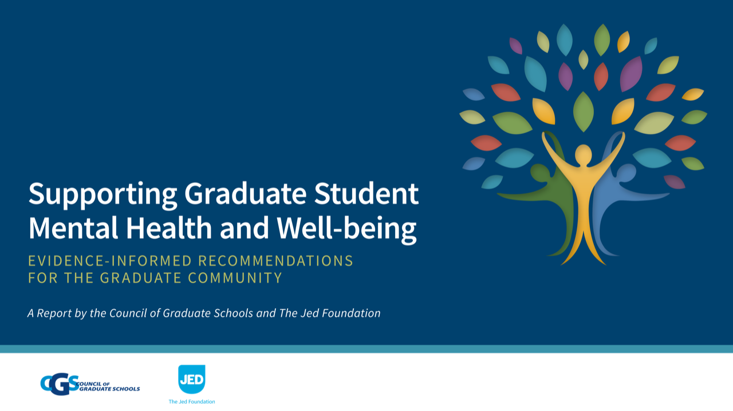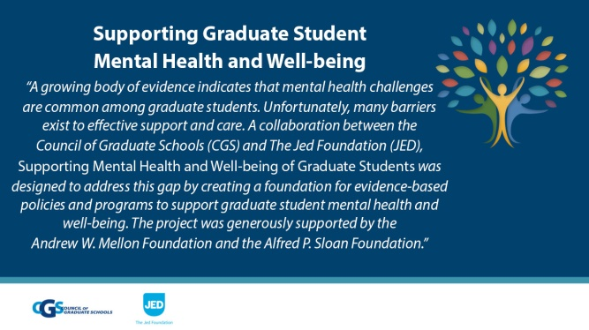
We are proud to be one of 150+ institutions to endorse the @CGSGradEd and @jedfoundation “Statement of Principles & Commitments of Graduate Deans,” to support graduate student mental health and well-being. https://bit.ly/3aHXGJa
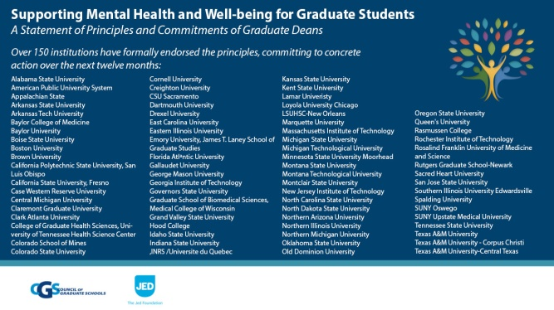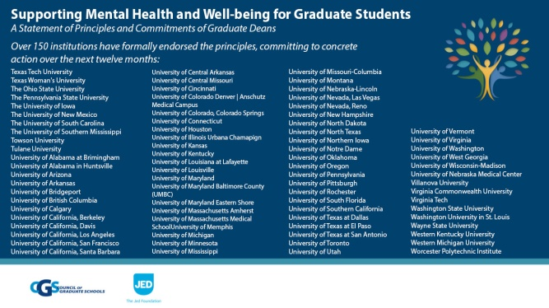
Part of @CGSGradEd @jedfoundation report is “Statement of Principles & Commitments of Graduate Deans,” providing institutions blueprint to support academic success, well-being of all students. As of today, 150+ IHEs have endorsed principles & commitments. https://bit.ly/3aHXGJa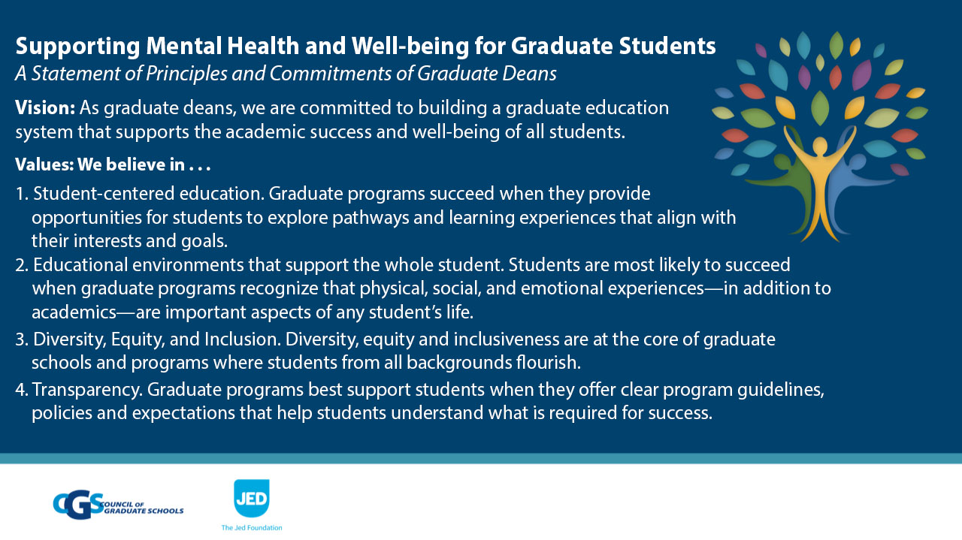 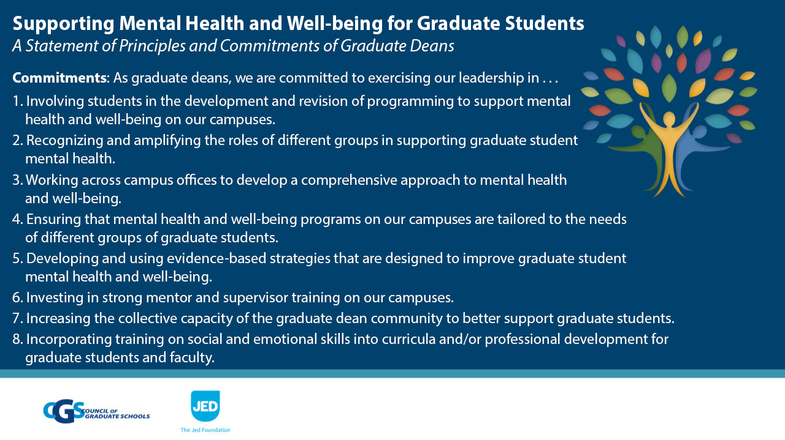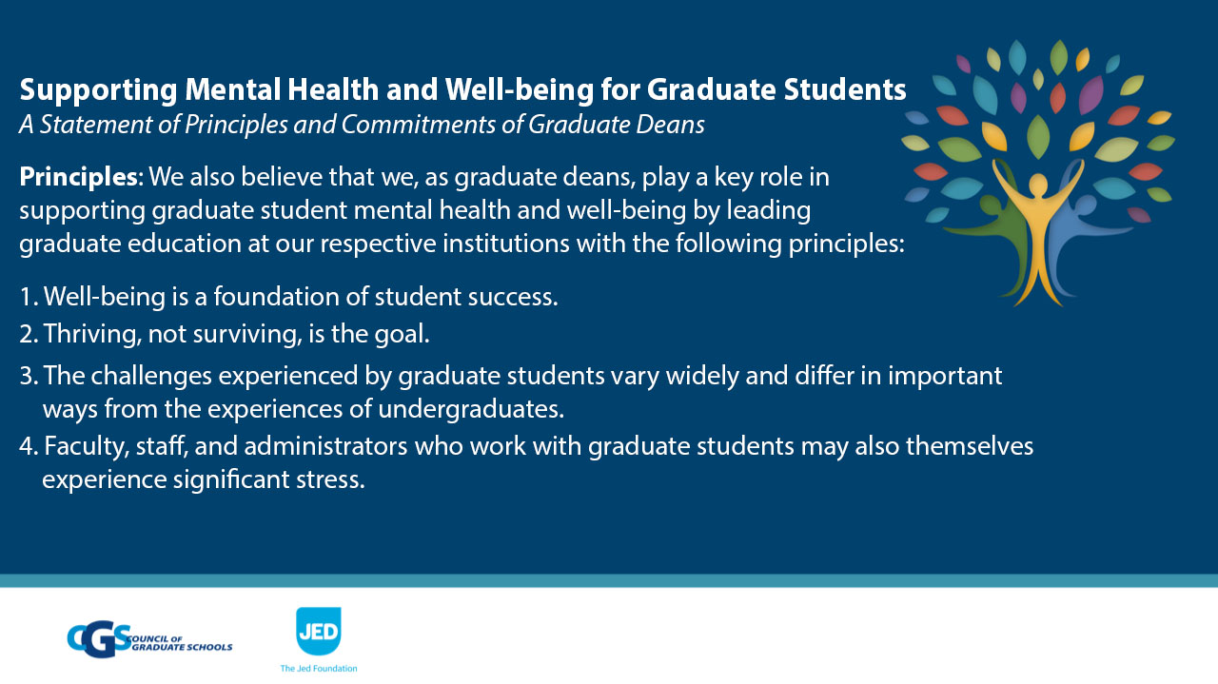 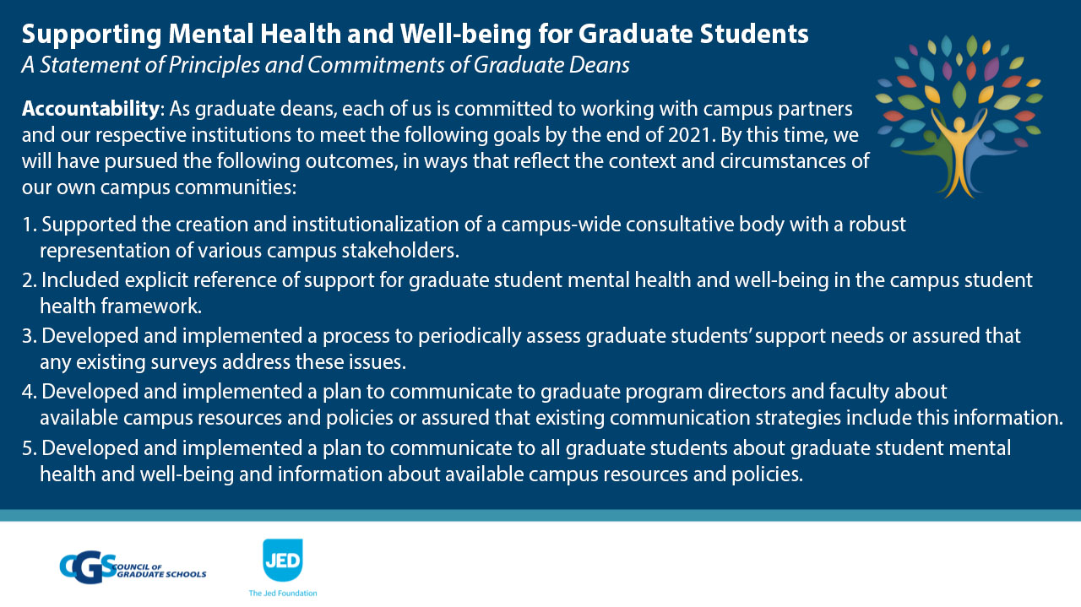
(Continued next page)
Report from @CGSGradEd @jedfoundation includes Recommendations for campus stakeholders (presidents, provosts, senior leaders, grad deans/ program directors/ faculty, grad students, funding agencies) and Priorities for Future Study https://bit.ly/3aHXGJa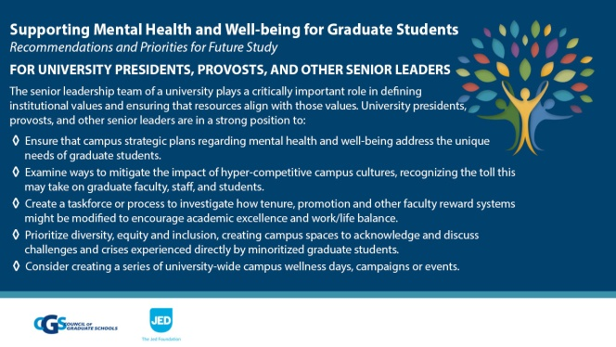 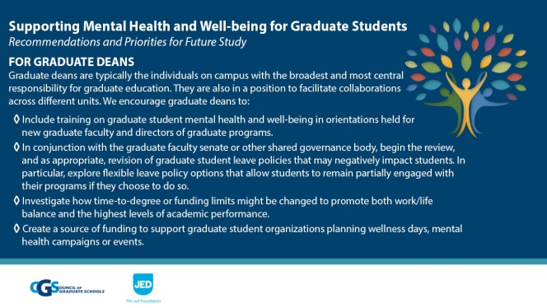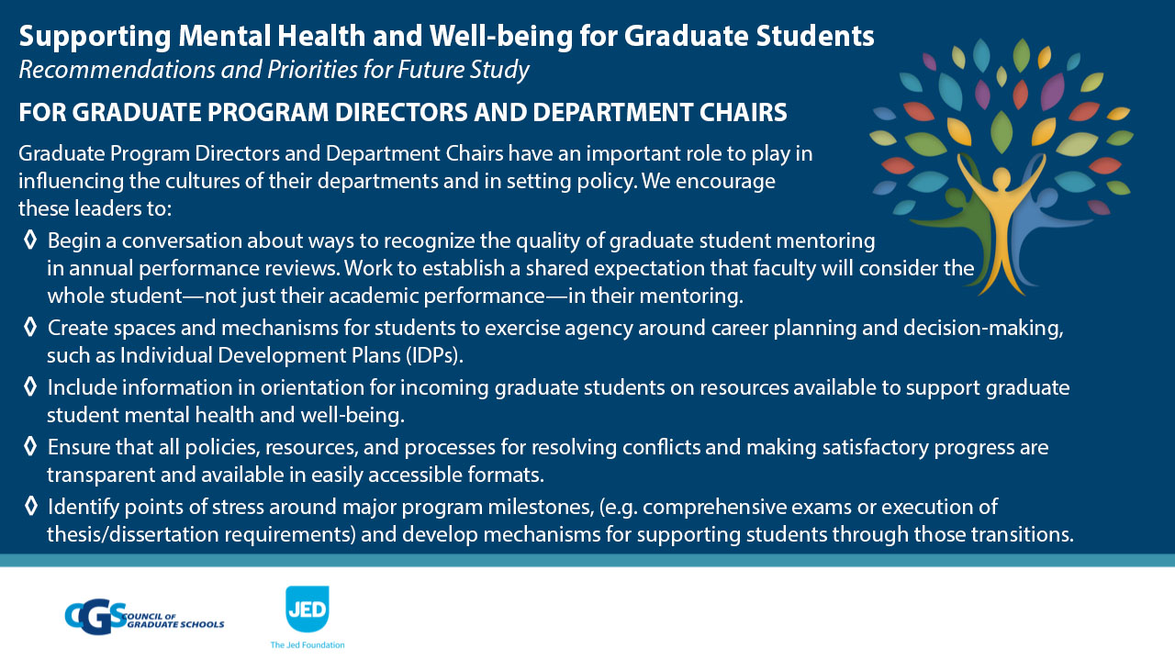 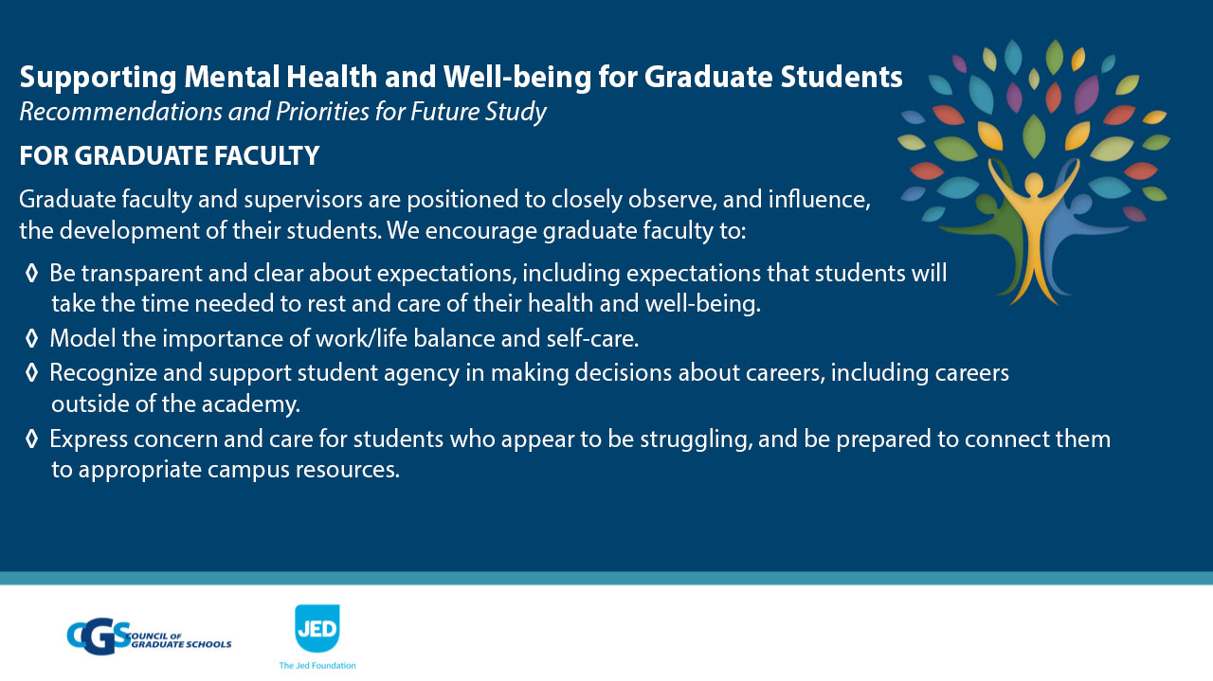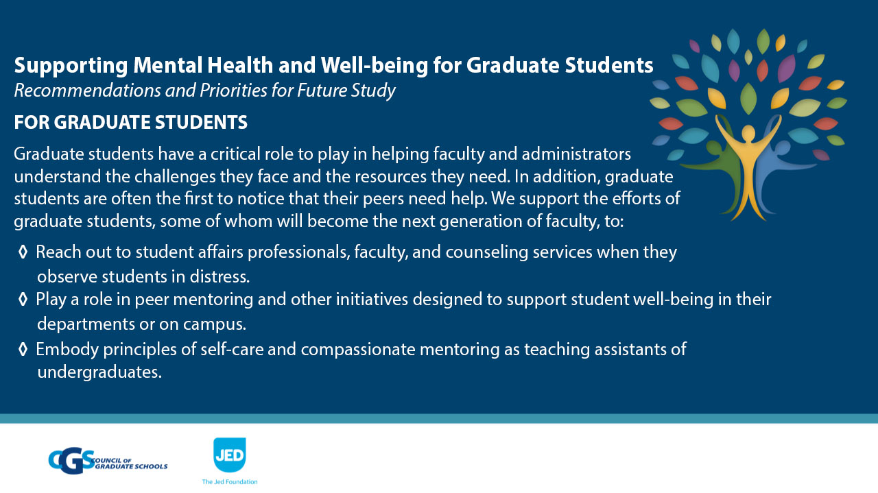 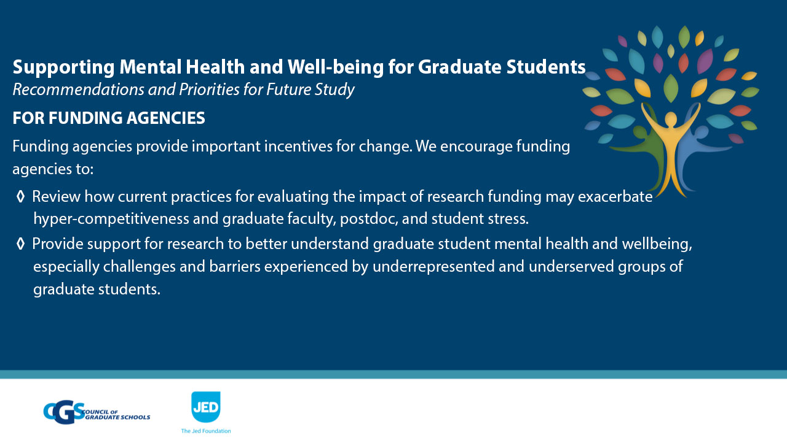
Findings in @CGSGradEd @jedfoundation report: While only 24% of grad deans indicated campus-wide strategic plan/vision/mission statement specifically references grad students, 49% noted institutions have taskforce/committee for grad student well-being. https://bit.ly/3aHXGJa
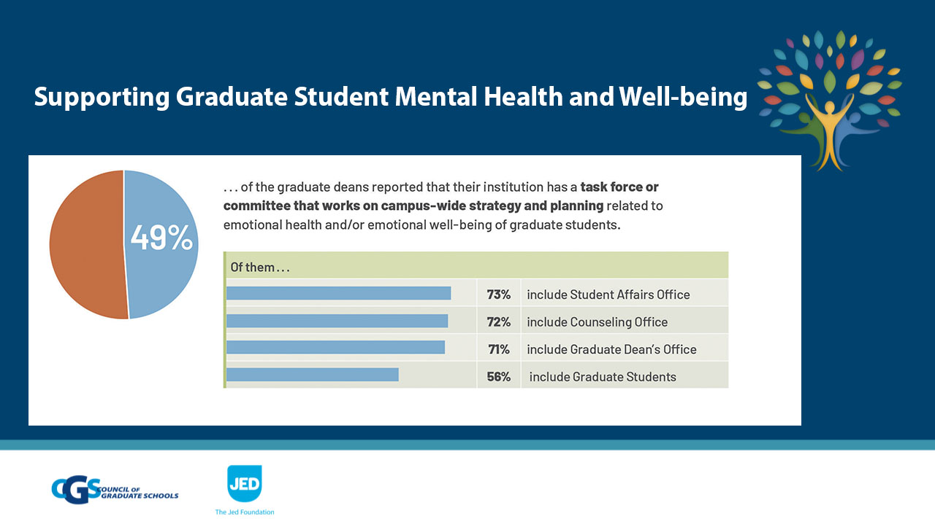

(Continued next page)
Findings in @CGSGradEd @jedfoundation report: 58% of grad deans reported their institution has a model, framework, or plan to promote grad student mental health and well-being. https://bit.ly/3aHXGJa
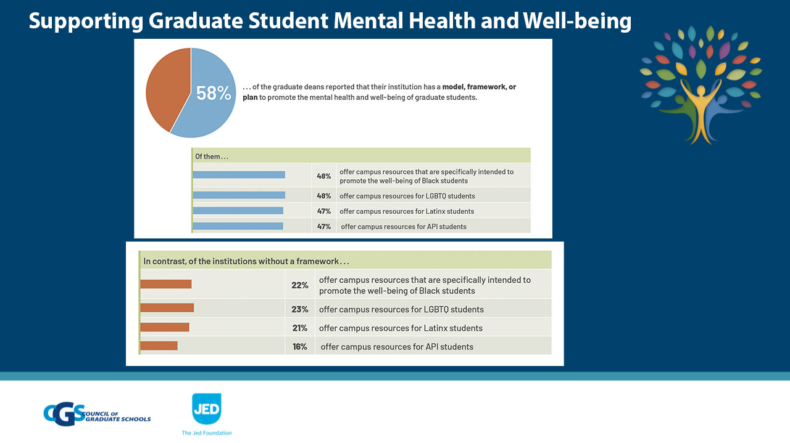
Findings in @CGSGradEd @jedfoundation report: 64% of grad deans reported their institution has collected data to assess grad student mental health and well-being in past 4 years. https://bit.ly/3aHXGJa
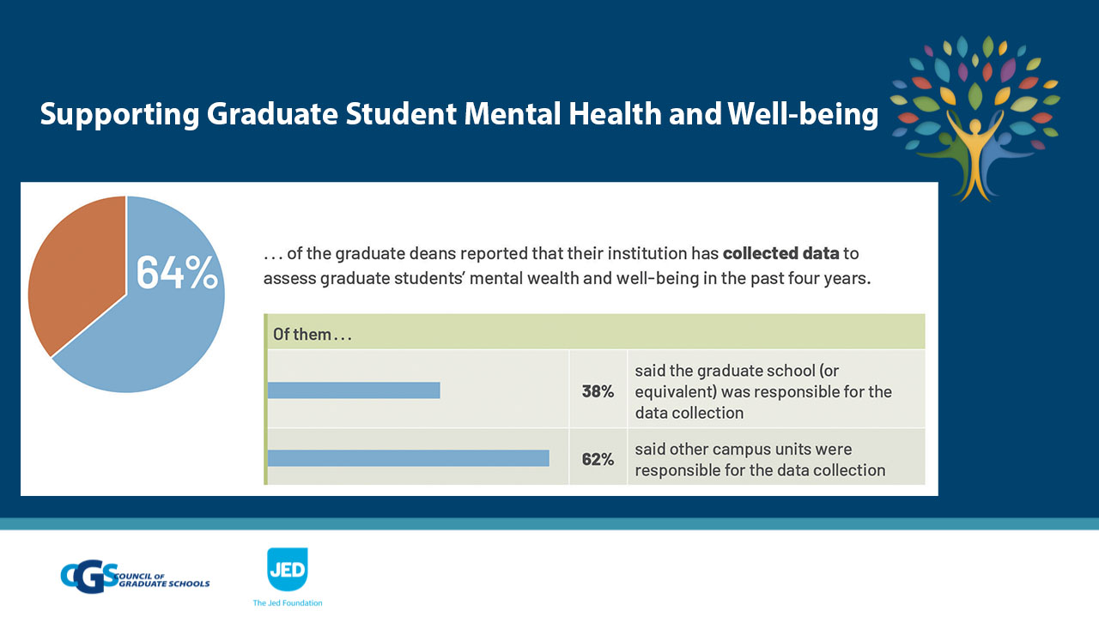
.@CGSGradEd @jedfoundation report highlights need to prepare more diverse workforce and calls for more equitable and supportive environments where ALL students thrive. https://bit.ly/3aHXGJa
